

S.M.A.R.T. Alarm:

Smoke Monitoring and Reactive Tasking Alarm

Senior Design 1

Project Documentation

Spring 2017

Group A

**Carlos Castro**, Computer Engineering

**Courtnie Coleman**, Electrical Engineering

**Lucas Plager**, Computer Engineering

**Patrick Schexnayder**, Electrical Engineering

# Table of Contents

Table of Contents i

List of Figures iv

List of Tables v

List of Equations vi

1.0 Executive Summary 1

2.0 Project Description 2

2.1 Motivation 2

2.2 Goals, Objectives, and Function 3

2.3 Engineering Requirements/Specifications 4

2.3.1 Smoke sensors 4

2.3.2 Transmitter and receiver 4

2.3.3 Software 4

2.3.4 Battery 4

2.3.5 Lights, Direction Indicator, Sound 4

2.4 House of Quality (Write about HoQ) 5

2.5 Block Diagram (Hardware/Software) 6

2.6 S.M.A.R.T. Alarm Operations Manual 7

3.0 Project Research 7

Existing Fire Detecting and Alarm Systems 7

Contemporary Installation Methods for Fire Alarm Systems 7

Fire Alarm System Components 8

Control Panels 8

Fire Sensors and Detectors 8

Smoke Detecting Sensors 10

Overview 10

Photoelectric Sensors 11

Ionization Sensors 11

Carbon Monoxide/Gas Sensors 12

Heat Sensors 13

Dual Sensor Technology 13

Conclusion 13

Assessing Fire Detection Options 14

Smoke Chamber Design 14

Infrared LED 14

Photodiode 15

MQ-2 Sensor 16

Fire alarm batteries 16

Shelf-life 17

Performance 17

Cost 17

Power and Capacity 17

Fire alarm sound and signaling 18

Sounders 19

PS1927P02 Piezo Sounder 19

PS1920P02 Piezo Sounder 20

PS1740P02E Piezo Sounder 21

12 VDC PUI Programmable Buzzer 22

Wireless Communications 23

1.1 Overview 24

1.2 Wireless Fidelity (Wi-Fi) 24

1.3 Bluetooth 25

1.4 ZigBee 26

Controller Hub 27

Arduino Uno 28

Raspberry Pi 29

BeagleBone Black 30

Hub Comparison Conclusion 31

Fire Alarm Components 32

Microprocessor for Fire Alarms 32

Bootloader 33

Bootloading Process 33

16 MHz Crystal Oscillator 35

4.0 Design Constraints and Standards 36

Constraints 36

Economic Constraints 36

Environmental Constraints 36

Social Constraints 36

Political Constraints 36

Ethical Constraints 36

Health and Safety Constraints 36

Manufacturability Constraints 36

Sustainability Constraints 36

Standards 36

5.0 Project Design 36

Hardware Design 36

Software Design 36

Hub Software/Network Overview 36

Wireless Network Design 38

6.0 Administrative Content 38

Estimated Budget 38

Actual Expenditures: Prototype 38

Financing Plan 38

Project Timeline 39

7.0 Conclusion 40

8.0 Appendix 42

8.1 References 42

8.2 Copyright Permissions 43

8.3 Datasheets 44

# List of Figures

Figure 1: House of Quality Diagram 5

Figure 2: S.M.A.R.T. Alarm System Block Diagram 7

Figure 3: Photoelectric Sensor No Smoke Present (left) 8

Figure 4: Photoelectric Sensor Smoke Present (right) 8

Figure 5: Ionization Sensors No Smoke Present (left) 9

Figure 6: Ionization Sensors Smoke Present (right) 9

Figure 7: MQ-2 Flammable Gas & Smoke Sensor 13

Figure 8: 12 VDC PUI Programmable Buzzer 20

Figure 9: Wi-Fi Network 21

Figure 10: ZigBee Star Network 24

Figure 11: Arduino Uno 25

Figure 12: Raspberry Pi 26

Figure 13: BeagleBone Black 27

Figure 14: ATmega328P Microprocessor 29

Figure 15: Arduino Loading Bootloader to Microprocessor 31

# List of Tables

Table 1: Average Ambient Noise Level and Minimum Required for SPL 16

Table 2: Square Wave Drive for PS1927P02 Piezo Sounder 17

Table 3: Square Wave Drive for PS1920P02 Piezo Sounder 18

Table 4: Square Wave Drive for PS1740P02E Piezo Sounder 19

Table 5: Specifications for 12 VDC PUI Programmable Buzzer 20

Table 6: Comparison of Development Boards 28

Table 7: Estimated Budget 33

# List of Equations

# Executive Summary

Every year many lives are lost in fires in both residential and commercial across the world. With as many precautions and safety measures taken to prevent fires, and to alert people of fires many times the confusion of such an event leads to loss of life. The confusing nature of an unfamiliar building layout and the lack of information about the fire, and most importantly its location, are factors that if addressed properly can severely reduce the current amount of fire-related deaths and injuries. In the situation of a fire, time is a factor and even a few seconds can make the difference between survival and death, and the S.M.A.R.T. Alarm system aims to address the issues of the lack of knowledge regarding the location of the fire, and finding the fastest evacuation route of a building. This is done by alerting those in the building of which route to take when evacuating a building while taking into account the locations where there might be the danger of fire, using a combination of audio and visual signals that will lead to an effective, fast and smart evacuation of a building.

Smart alarms currently on the market, may track the location of the fire for the purpose of giving the information to fire departments for controlling and extinguishing the fire. However, the occupants of said building are not alerted of this and taking a wrong turn can be deadly for an evacuee. S.M.A.R.T Alarm stands for Smoke Monitoring and Reactive Tasking Alarm, and its purpose is to fulfill what its name stands for, by monitoring for smoke or fire and alerting the occupants of a building how to react.

The system consists of a Central Processing Hub, connected to AC Power, that is in constant communication with all of the Fire Alarms in the system, via wireless communication using ZigBee Radio Modules. Each individual Fire Alarm in the network is powered primarily by constant AC Power from the building’s power grid and backed up by a 9V battery in case of power going out in the building. A Fire Alarm device is constantly sampling the air using an IAFF approved fire and smoke detecting method and sensor. If any of the alarms sense a fire or smoke, a data packet will be sent to the Central Processing Hub, informing it of the potential for fire and knowing the location of the specific Fire Alarm. The Central Processing Hub can use this information to calculate the most efficient evacuation routes based around avoiding the fire and evacuating occupants as quickly as possible, using the Directional Evacuation Algorithm. The Central Processing Hub will then inform each Fire Alarm of the signals they must sound and display based on the evacuation routes. This will result in alarms playing the sound in a synchronized manner, where the sound will echo toward the nearest exit by playing alternating sound from the speakers and allowing occupants to “follow” the sound to the exit. At the same time, each alarm will display an arrow that will point in the direction they must follow for the evacuation route. In case of low power or low battery power, the Central Processing Hub will push notifications to the building manager using a connection to the building’s Wi-Fi network, so that they may address the issue and perform the necessary maintenance.

The S.M.A.R.T Alarm System is designed for easy installation, that requires the installer to access a custom program run on the Hub using the Microcontroller’s operating system. There a layout of the building may be designed and locations of the Fire Alarms may be marked, following that the system will be ready to monitor the building for fire and save lives.

This report documents the S.M.A.R.T. Alarm System design process. This report begins by relating the motivation, goals and function behind this project, followed by a more in-depth look at the engineering requirements and specifications and the operation of the system. The research chapter takes a detailed look at current systems and based on the information collected components to be implemented in the system. Some of the more important components selected as a result of the research performed in this section include the microprocessor to be used, the smoke and fire monitoring sensor, the microcontroller tasked with being the Central Processing Hub, Wireless Communication methods and various alert components. Following the Research chapter, the topics of several constraints considered in designing and implementing this system are considered such as economic and environmental constraints. This section will also include standards that are to be considered in the design process such as IEEE and NFPA. Following this, the design section will discuss the intricacies of hardware, software, and network design. This includes the schematics, block diagrams and other related documentation that are used for planning and designing the system. The hardware section will focus on PCB design for the Fire Alarms, while the software section will focus on programming the direction algorithms. The Administrative Content section goes into details regarding the budget and actual expenditures, as well as the project timeline and the such.

# 2.0 Project Description

## 2.1 Motivation

In today’s day and age, technology advancements are occurring at a rapid pace. There are new inventions being created every minute improving people’s lives and making the world a better and safer place. Our group saw that while technology is advancing and becoming a bigger part of our everyday lives, one piece of technology that has not seen a major improvement in decades is the smoke and fire alarm. This device is a standard in everyone’s homes, offices, hotels and all other major buildings that we spend time in every single day but has been neglected as far as engineering advancement and innovation is concerned. The smoke and fire alarm that you have inside your house is essentially the same one your parents had inside theirs. We think we can do better. When looking at the average use case of a smoke detector, it was discovered that while they are useful, these devices do not provide the user with an abundance of information. Frequently, someone would hear the alarm go off and just frantically run to wherever they believe to be the nearest and safest exit without much of a plan. This scenario has the potential for disaster when you consider that there could be multiple people inside the building who do not know their way around and could be endangering themselves. Individuals could be wasting valuable time or be heading in a direction that is dangerous. We believe that a smoke alarm with improved functionality can help to eliminate this scenario and make everyone’s lives easier, and most importantly, safer. This can be achieved by creating a more connected fire alarm system. When the location of a fire is a factor in directing evacuation of a building, communication between the detection system and alarm system can provide crucial, life-saving information.

## 2.2 Goals, Objectives, and Function

The goals for the smart smoke and fire alarm are to make an affordable, customizable, connected system of smoke alarms that alert employees and residents of the safest and fastest exit of the building in the case of a fire emergency. We would like this system to not be that much more expensive than existing options to convince the market to adopt our system. In the event of an emergency, these smoke alarms would sound off in an order that would lead people to the closest and safest exit. Users would just have to follow the sound that is projected from these alarms until they reach the exit to the building. These smoke alarms would be dynamic in the sense that they adapt to where the fire is located. This means that if a smoke alarm that is in the middle of a hallway goes off, people on the left of that area would be directed to the exit that is closest on their side of the fire while people on the right of that area would be directed to the exit that is closest on the other side of the fire while nobody is directed though the dangerous area. The system would also be able to handle hallway intersections and other confusing areas. This allows for residents to know where the fire is and what areas to avoid. For people that have hearing issues, these alarms will also have a visual display using light-up arrows that will point individuals in the direction they should go to exit the building. This also allows for better handling of confusing areas where sound alone could be confusing. This system should be achieved by mapping the building layout using a custom-made application during set up of these alarms, creating spatial awareness for each of the fire alarms, while using an algorithm to signal each alarm which is the best exit direction relative to its position. Our final goal is to focus on the ease of installation of our system. This system needs to be simple enough to install so that specialists are not required to configure, set up, and install these fire alarms. An effective ease of installation would ensure that almost anyone would be able to adapt our system into their building plans.

## 2.3 Engineering Requirements/Specifications

The fire alarm that will be designed will give a clearer indication as to where to go during a fire. For this system to work each alarm will be connected to each other and will be able to send and receive signals. This system will be mapped to the floor plan of the building, so that when a fire breaks out the alarm system will recognize where the fire is coming from and send out a signal to each alarm to light the LEDs in the direction people should go to get away from the fire.

### 2.3.1 Smoke sensors

Smoke sensor will be used to detect smoke within the building, there are different types of smoke sensors to detect fast flaming fires and slow smoldering fires. Upon more research we will be decided which would be best for us to use within our fire alarm. We want to make sure that we have the most cost-effective sensor that are also very efficient, to provide the costumer with the best product.

### 2.3.2 Transmitter and receiver

For this fire alarm system, we want to make sure to direct the people away from the fire and to the closest exit. For this to work we will need each alarm device to be connected to each other. So each separate alarm will have a transmitter and a receiver so that way each alarm would be able to communicate to each other, and send the correct signal.

### 2.3.3 Software

For the fire alarm system to be successful we will be using a script language to program the devices to recognize the layout of the building, and to be able to set off the sequence as to where to go when one of the smoke sensors go off. It has not yet been determined which script language will be use yet, we want to make sure you use the one that would be the most efficient and easy to implement.

### 2.3.4 Battery

For the fire alarm system, it will be using a 9v battery with 1200 mAh current, due to some research on current fire alarm systems and the profession grade batteries they use. We are also researching the different types of batteries that would provide us with the best life expectancy. We would want the battery to have a life expectancy that will last between 5 to 10 years. This way the alarm system requires minimal maintenance as possible, on top of annual inspections.

### 2.3.5 Lights, Direction Indicator, Sound

To help with the indication of a fire, and to help direct people in the right direction away from the fire there will be two LEDS in the shape of arrows on the fire alarm. Depending on the signal that is sent out, one of the arrows would illuminate in the direction to go. This will help give a clearer indication as to where the fire maybe and where to go. In addition to the lights and the direction indicators, there will also be an echoing sound that will sound when the alarm goes off. This echoing sound will follow the sequence of the signal that was sent out, and the sound will go towards the closest exit, just like the lights.

## 2.4 House of Quality (Write about HoQ)



Figure : House of Quality Diagram

## 2.5 Block Diagram (Hardware/Software)

The layout of the S.M.A.R.T. Alarm system consists of two types of devices, a central processing hub, known as “The Hub” and each Fire Alarm. The Hub will consist of a main alert computation system that includes the CPU for this device, which will be able to process any information received from the Fire Alarms in the same system through a wireless communication network, therefore The Hub will also require a communication module component in order to receive and transmit this information. The Alert Computation System will be in charge of using the data received and making any decisions necessary for the system, and instruct each individual alarm of the appropriate response in its specific case based on location. This Alert Computation System is also in charge of creating any alarms and pushing them to any users in charge of maintenance of the system so that they may perform any maintenance required. The Hub will receive Power from an AC outlet connected to the building’s power grid.

The Fire Alarms consist of several component blocks. The Fire Alarms will rely heavily on the communication module that allows wireless communication between the alarms and The Hub. This communication component block will be in communication with the Fire Alarm System that contains the CPU of the device. This component block will make any decisions for the individual alarms, including but not limited to deciding whether the data received from the Sensors block requires alerting The Hub of a potential fire, checking the Power Status block for the status of the primary AC power and the backup 9V Battery Power. The Fire Alarm System Component block is also in charge of managing the Alert System Component block in case it receives a message from The Hub that the fire alarms should sound, this message will also tell the CPU how to direct users in case of fire through the Alert System Block. Ideally, in the actual system there will be several of the Fire Alarm Devices communicating with The Hub, and for the purposes of demonstrating the project, the final project product will contain 5 Fire Alarm devices and one Central Processing Hub to manage them.



Figure : S.M.A.R.T. Alarm System Block Diagram

## 2.6 S.M.A.R.T. Alarm Operations Manual

# 3.0 Project Research

## Existing Fire Detecting and Alarm Systems

### Contemporary Installation Methods for Fire Alarm Systems

When building commercial buildings there exists many different companies that provide fire safety systems. These systems come in many different configurations with different components that can be added to provide different features. The key task for all of these different systems is to identify an emergency in a timely manner and give notice to all of the buildings’ occupants of this emergency. Advanced systems also allergy the fire emergency organizations so fire fighters can address the emergency as quickly as possible. These fire alarm systems provide a way of identifying a developing fire emergency through both manual methods and automated methods. These systems then all have the task of alerting all building occupants that they need to evacuate the building and remove themselves from danger. After these two basic tasks have been completed, the stage of optional and additional processes can be added. This is where the different companies and components come in. A common function is the transmission of an emergency notification signal to the fire department and other emergency response organizations. More advances systems may even shut down electrical processes throughout the building, air conditioning equipment and other systems that may be more vulnerable to fire emergencies or deemed dangerous and may make fires worse. Automatic suppression systems such as water sprinklers can also be added. Below we will describe these different components that can be added to current fire alarm safety systems.

### Fire Alarm System Components

#### Control Panels

Today’s systems generally have a central control panel. The control panel is responsible to keeping track of the various alarm input devices that are installed throughout the building. This includes both manual and automatic sensors. The control panel also has the task of sending signals to the various output devices installed throughout the building. These output devices can include bells, warning lights, emergency telephone calls, and horns. Control panels can range greatly in complexity. They could be as simple as panels with only one area to keep track of with inputs and outputs all from this one zone. They could also be very complicated controlling very advanced systems encompassing multiple floors of multiple buildings throughout an industrial complex. When choosing a control panel, the decision comes down to deciding between two general fire alarm systems. These are conventional systems and addressable systems. These two systems are covered in a later section of this document.

#### Fire Sensors and Detectors

The first and most basic type of fire detectors available are manual sensors. People have the ability to sense many different aspects of a fire emergency. This includes heat and flames themselves in addition to smoke and odors. This is also obviously the cheapest way of detecting if there is a fire emergency because advanced sensors and systems do not need to be purchases. For this reason, most fire alarm systems that can be purchased today come with the installation of manual alarm devices. These devices are used by whoever detects the fire emergency.

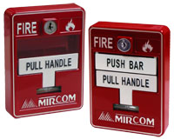Unfortunately, there are the obvious risks associated with only using human input for fire detection. A person needs to be present at the time of the emergency in order for this system to be of any use. The person needs to also remember to pull the alarm in the event of an emergency. A person’s ability to act in the event of an emergency in not something that would want to be relied on. Lastly, this system relies on a person’s ability to detect an emergency in a timely manner. For these reasons, a large assortment of automatic fire emergency detection devices has been developed. These devices are meant to mimic a person’s natural senses. There are devices that mimic a person’s sense of touch by measuring heat. There are also devices that mimic a person’s sense of smell by measuring chemicals, smoke and odors. Flame detectors are also made to mimic a person’s sense of sight. A current and effective installation of a fire system would use these types of devices in order to best detect emergencies and protect building inhabitants. These manual fire detection systems are generally connected directly to manual alarm stations. Pull switches are connected directly to alarm systems so that users to not have to scream throughout a large commercial building. The key issue with these systems, as discussed earlier, is that this is not an effective system if the structure is unoccupied. These systems also open the building up to false alarms by kids that are looking to have fun or criminals.

Figure : Manual Pull Alarm

The first type of automated sensor used in commercial buildings was the thermal detector. These units are usually set to go off when a room reaches a designated temperature. This temperature is commonly set between 135 and 165 degrees Fahrenheit. Temperature alarms also can go off rate of change of temperature instead of a preset temperature. These types of alarms go off when the temperature of a room heats up an abnormally fast rate. Thermal detectors can be highly reliable and resistant to false positive alarms. The temperature of a room rarely heats up to a high temperature or heats up at a abnormally fast rate if there is not an emergency present in the room. These alarms do have a major downside however. Since these alarms do not function until a certain heat condition has been reaches, this provides for the opportunity of a lot of damage to the room before the sensor goes off.

The second type of automated sensor used in commercial buildings is the smoke detector. These devices are effective because they are designed to detect smoke which usually occurs in the early stages of a fire emergency. Most of these devices use a type of light sensing system that detects if there is smoke by sensing the disruption in a light beam caused by smoke. Smoke alarms are usually installed in the same manner as thermal detectors. They are usually installed either on ceilings or high on walls in hallways. Because of a smoke detectors ability to detect a fire in its early stages, they can allow enough time for fire emergency personnel and response teams to reach a fire emergency in a timely manor. This can help to prevent damage to the building as well as help to get occupants out of the building before it is too late. For this reason, they are usually preferred over thermal detectors when choosing between the two systems. There does exist downsides to smoke detectors, however. They are usually more expensive to install in high quantities throughout an entire building. When it comes to fire safety, however, cost should take a back seat to people’s lives. The other disadvantage to smoke detectors is that they are prone to false positives. They can go off because of a simple cigarette or burned food when cooking. A professional installer should be able to install these devices to limit the chance of false readings.

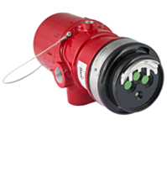The last type of automated sensor that is used in commercial installations of fire alarm systems is the flame detector. Just how the thermal sensor imitates the sense of touch and the smoke detector imitates the sense of smell, the flame detector imitates a person’s sense of sight. These devices use line of sight to detect flames and operate on either infrared or ultraviolet signals. These devices look for a high level of radiant energy and alerts a fire alarm panel of an emergency. These devices are very reliable as there are very few things that could produce the radiant energy of a fire without there actually being a fire. These devices are usually installed in high priority manufacturing environments. The major disadvantage to these systems is that they can be very expensive to install and labor intensive to keep operating at top efficiency. Another major disadvantage is that they must be looking directly at the place where a fire will occur. For these reasons, flame detectors are generally relegated strictly to manufacturing environments where corporations need the high-quality systems in areas where fires can be expected.

Figure : X3302 Multispectrum Infrared Hydrogen Flame Detector from Det-Tronics

## Smoke Detecting Sensors

### Overview

The two most commonly used types of sensors for used in domestic and commercial smoke detectors are Photoelectric Smoke Detection Sensors and Ionization Detection Sensors. These sensors may be used individually in commercially sold smoke detectors, used in combination with each other, and also in combination with Carbon Monoxide/Gas Sensors or Heat Sensors.

### Photoelectric Sensors

The Photoelectric Sensor, is often considered to work as an “eye” due to the nature of how it detects smoke. The sensor typically consists of a using a light source that emits infra-red light, an LED is commonly used, a lens for directing the light and a photoelectric receiver, such as a photodiode, that is the target of the infra-red light. These are placed in a chamber that is open to the air, and when smoke is present, will be filled with smoke particles. Smoke particles will cause the light to scatter and affect the amount of light that comes in contact with the photoelectric receiver. This will then result in a drop in current across this sensor, which is sensed by the circuit attached and the alarm is activated accordingly. This type of sensor is typically placed on or near the ceiling of a room, as smoke tends to rise and this allows for a better reaction time in case of a fire. This alarm is also less sensitive to false alarms that result from minor smoke from candles, steam or cooking. This type of sensor is also known to react more quickly to smoldering fires, as these fires tend to produce larger combustion particles that interact well with the sensor, however it still has a good detection time for flaming fires. (Bukowski, Performance of Home Smoke Alarms).

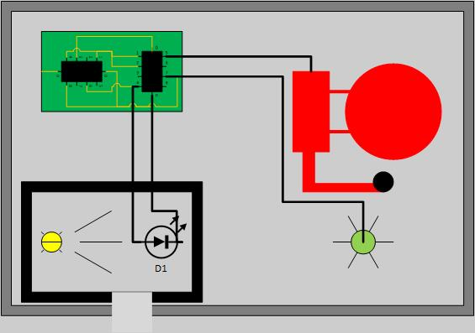 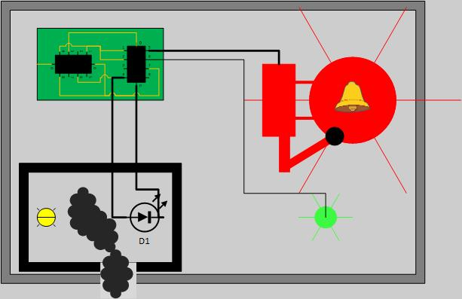

Figure : Photoelectric Sensor No Smoke Present (left)

Figure : Photoelectric Sensor Smoke Present (right)

### Ionization Sensors

The Ionization Sensor is considered a cheaper alternative to using a Photoelectric Sensor. Like a Photoelectric Sensor it can also sense smoke particles in the air that are generally not big enough to see with the naked eye. This sensor is comprised of two ionization chambers that create a current using the potential difference across two electrodes contained inside. A reference chamber has no particle entry while the other chamber is open to the air and would potentially allow for smoke particles to enter. Both chambers contain a small amount of Americium-241, a radioactive material that emits “alpha particles” which result in positively charged ions and negatively charged electrons when they collide with air particles. The electric charge of the ions creates a potential difference across the pair of electrodes and allows a current to flow across the sensor. The expected current should be the same in both chambers, as they are both facing identical conditions including air pressure, temperature and aging of the Americium. If any smoke particles enter the test chamber, ions will begin attaching to those particles and the current will not be carried across the chamber. Thus, the circuit attached will detect the current difference between the test and reference chambers and activate the alarm (Cote Principles of fire protection p 249). Once this smoke clears, the ions will begin to flow between the electrodes again and current should return to the reference level. The current draw of an Ionization Sensor is low, therefore a small battery is sufficient for powering this circuit long term. Ionization Sensors are known to quickly detect small amounts of smoke, generally produced by flaming fires fueled by paper and flammable liquids and thus is prone to false alarms (<http://www.asecurelife.com/best-smoke-detector>).

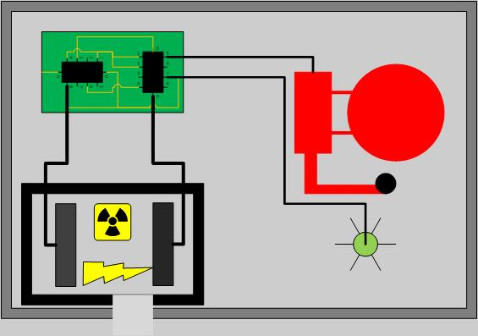 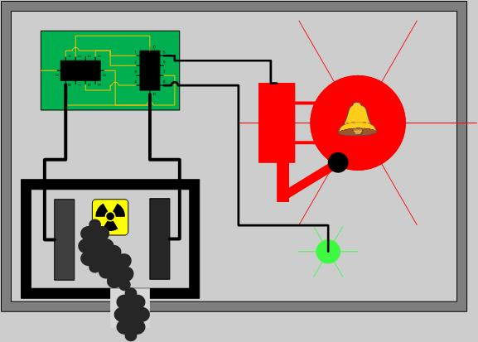

Figure : Ionization Sensors No Smoke Present (left)

Figure : Ionization Sensors Smoke Present (right)

### Carbon Monoxide/Gas Sensors

Carbon Monoxide Sensors are generally intended to sense deadly levels of carbon monoxide, and alert those present, usually sleeping, of the presence of the gas, so that they may escape or clear the air. These tend to respond to all scenarios of fires, and has a faster response time for flaming fires in comparison to smoldering fires, however it greatly increases response time for smoldering fires when compared to both smoke sensors. This would be ideal if used in combination with the Photoelectric or Ionization sensor, however not essential or entirely reliable as a sole sensor, due to not all fires producing large amounts of carbon monoxide (Bukowski Performance of Home Smoke Alarms).

Gas sensor modules have a steel exoskeleton for protecting the sensing element, which has current running through leads that connect, known as the heating current. Gases coming close to the sensing element are ionized and absorbed by the sensing element. This results in a change in the resistance of the sensing element and thus a different current value stemming from the sensing element. The steel mesh around the sensor is designed so that suspended particles are filtered and only gases pass into the sensor (https://www.engineersgarage.com/insight/how-gas-sensor-works).

### Heat Sensors

Heat sensors feature a detecting element, such as thermistors, that activate when a predetermined temperature or a previously specified temperature increase occurs in the sensor (https://www.grainger.com/content/qt-types-smoke-alarms-detectors-366). The best applications for using these sensors are “small confined spaces where rapidly burning, high heat fires are expected” (https://www.grainger.com/content/qt-types-smoke-alarms-detectors-366). These tend to have low false alarm rates, however due to the slow detection time for both smoldering and flaming fires (Bukowski, Performance of Home Smoke Alarms) it is not very effective in residential fires.

### Dual Sensor Technology

Commercially sold smoke alarms may also contain a dual sensor technology, that while it may be more expensive, the use of both photoelectric and ionization sensors allows for a functionality that quickly detects flaming and smoldering fires. However, the IAFF announced at their 2008 conference that they officially recommend photoelectric sensor alarms and stating dual sensors are no longer acceptable as the technology in ionization sensors tends to lead to a delay in sensing smoldering fires, in addition to having difficulties to high airflow environment, which would lead to an even greater delay (<http://www.thewfsf.org/iaff>). The Ionization sensor’s susceptibility to false alarms is also problematic when creating a smoke detector and alarm system that the users can trust.

### Conclusion

Due to the recommendation by the IAFF of using solely Photoelectric Sensors in a smoke alarm due to its fast response time to smoldering, over using Ionization Sensors or dual sensors, as well as the common use of Photoelectric sensors in public areas fit for large domains and the sensors simplicity, the Photoelectric Sensor will be implemented in the S.M.A.R.T Alarm system. Ionization Sensors may provide the fastest response time for more noticeable flaming fires, but the average response time of a Photoelectric Sensor is comparable according to the NIST study (Bukowski, Performance of Home smoke alarms). The use of Carbon Monoxide sensors could also be implemented, as it may increase response time for smoldering fires, the use of a Photoelectric Sensor is sufficient for targeting this type of fire, however for testing purposes it would remove the necessity of creating fires that result in smoke, which pose several risks and inconveniences during the testing phase. Heat sensors will also not be implemented in the S.M.A.R.T. Alarm due to slow detection time, it would not add much to the system while increasing cost.

## Assessing Fire Detection Options

### Smoke Chamber Design

The S.M.A.R.T. Alarm system employs the use of Photoelectric Sensors to detect smoke. The use of these sensors requires the design and implementation of a “Smoke Chamber” that serves as a chamber where the ambient air can enter, and thus if smoke is present it may enter as well. The most effective way to place the smoke chamber would be to have any perforation on the underside of the alarm, so that the smoke can rise into the chamber while also avoiding any light that may come from windows or the ceiling from entering the chamber. The Smoke Chamber will have two main components: an infrared or ultraviolet light emitting diode (LED) as a source and a photodiode to act as a receiver. The LED is emitting light continuously at the photodiode, and as long as the photodiode is receiving this light a current is produced, therefore if this light is interrupted then the current will stop. A lack of current stemming from the photodiode will serve as a marker for the system that smoke is present and the alarm should sound. The smoke chamber should contain as little outside light as possible, so that the outside light does not interfere with the photodiode, while allowing enough air flow for smoke to enter the chamber if present. In fact, the design of the Smoke Chamber as a Photoelectric Sensor should serve as a black box, with an input to power the LED and an output from the photodiode, so that the Alarm circuit can measure to determine the presence of smoke.

### Infrared LED

Infrared radiation is a type of electromagnetic radiation that is often referred to as infrared light. Discovered in 1800 by Sir William Herschel, infrared radiation is invisible to the human eye however heat stemming from infrared can still be felt by touch, extending just past the red edge on the visible spectrum. Infrared radiation is classified as falling between the wavelengths of 0.75 um to 1mm. The IR LED used for measuring smoke presence in the Smoke Chamber serves as a low power option for transmitting the IR light meant to be received by the photodiode. This component must also provide the ability to emit the light normal to sensor, to avoid wear and tear that is associated with bending the leads of the component. The wavelength of the light transmitted should also match the wavelength of peak sensitivity for the photodiode, to ensure that the sensor will work.

### Photodiode

A photodiode is a semiconductor component designed to operate in reverse bias, that generates current when light is sensed and its photons are absorbed. However, it may also produce small amounts of current while there are no photons present. Generally, the response time of a photodiode decreases as the surface area increases in size. The most common photodiode is the solar cell, which employs its properties to convert sun light into electric current for common use. Photodiodes are not much different than regular semiconductor diodes, aside from being exposed to detect light or being designed with an optical fiber so that light to reaches the sensitive part of the component (Cox, Fundamentals of Linear Electronics).

The photodiode is a p-n junction, and when a photon with enough energy reaches the diode, an electron-hole pair is created, this is often referred to as the inner photoelectric effect. In case that the absorption occurs in the depletion region of the junction, the built-in electric field of the depletion region sweeps the carriers from the junction, and the electron-holes move toward the anode while the electrons move toward the cathode, creating a photocurrent. The total current of the photodiode is made up of the sum of the photocurrent and the dark current, the current that’s generated when the photodiode is not exposed to light. Therefore, to maximize the sensitivity of the device, the dark current must be minimized (Tavernier, Chapter 3: from light). Photodiodes are often operated in photoconductive mode, in which the diode will be reverse biased, resulting in a reduced response time as the width of the depletion layer is increased by the additional reverse bias, thus decreasing the capacitance of the p-n junction. The reverse bias will also increase dark current while minimally affecting the change in the photocurrent (http://hyperphysics.phy-astr.gsu.edu/hbase/Electronic/photdet.html).

However, when analyzing the viability of testing our system using a photoelectric sensor in a closed environment, we would have to create enough smoke each time we want to test the system. While this is possible, we would like to avoid the risk of creating an actual fire by burning components that would produce smoke as well as avoiding setting off the actual smoke and fire alarms in the building we are testing in. Performing tests outdoors is not very viable as there will be little control over weather and wind conditions, as well as limited access to lab materials for making any changes or fixing components of the system. Another possible roadblock is the burden of creating a working smoke detecting sensor, as this may take away from the true purpose of the project if implemented incorrectly or with error. This purpose of the project being creating a system for enhanced evacuation in the event of a fire, not creating a smoke detector. A carbon monoxide detector provides the most reliable sensor without having to create an actual fire with smoke in a lab setting.

### MQ-2 Sensor

This sensor has the ability to detect several types of gases: Hydrogen, Liquified Petroleum Gas, Carbon Monoxide, Alcohol, Smoke and Propane. The type of gas detected is transmitted by the analog output of the sensor as a certain range of values for each gas, it however cannot detect more than one gas at a time. This requires the sensor to be calibrated to detect a certain gas, in the case of this project the gas would be smoke. The MQ-2 Sensor has a standard input voltage of 5.0 V +/- 0.1 V, with an adjustable load resistance. The ideal operation temperature is 20°C +/- 2°C, with an ideal “preheat time” of 48 hours. Following this combustible gas and smoke will be easily and accurately detected for concentrations in the rate 300 to 10,000 ppm. The quick detection by the sensor coupled with the simplicity of implementation and use make this sensor the best option for this project, however for future projects the implementation of a photoelectric sensor would be recommended.

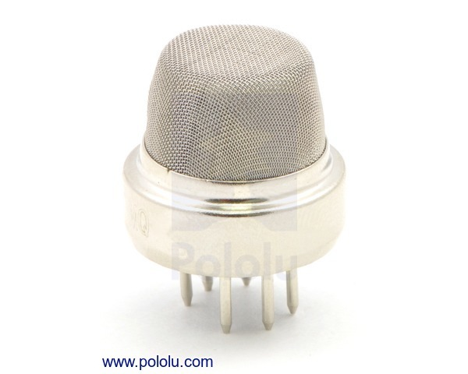

Figure : MQ-2 Flammable Gas & Smoke Sensor

## Fire alarm batteries

The battery that would be best for this SMART fire alarm system would be a 9V 1200mAh Lithium battery. The Ultra life 9V Lithium Battery is the perfect battery for low drain devices. Also, this battery has a long duration of shelf life at about 10 years, which is great for the fire alarm system. A long shelf life would help the fire alarm system be more reliable, and it will also require less maintenance. There are different types of batteries that we could use, alkaline or lithium batteries. As stated before, we chose to go with a lithium battery rather than an alkaline battery. When comparing the two different types of batteries we and see the difference between the two, and how we came to make this decision.

### Shelf-life

When it comes to shelf life, we chose to go with the lithium battery because lithium batteries can last much longer than an alkaline battery can. As mentioned above a longer shelf live requires less maintenance to be done with the smoke detectors, other than routine checks to make sure that everything is up to code. Therefore, requiring less maintenance allows the customer to not have to change the battery so often.

### Performance

Lithium batteries work well with devices that are low drain and high drain, whereas alkaline batteries don’t perform well with high drain devices, unless they are a special premium alkaline battery. Alkaline batteries are good batteries, just not for a smoke detector, a major problem with these types of batteries is that they are susceptible to self-discharging. This leakage could damage the device which could cause the smoke detector to malfunction and not go off which would endanger a lot of people. Lithium batteries are said to last about 7x to 8x longer than alkaline batteries. Also, it is mentioned that lithium batteries can withstand lower or higher temperatures depending on the environment that batteries are placed in. Opposed to alkaline batteries that can’t perform in those types of environments.

### Cost

The upside that we found with the alkaline batteries is that they are very low cost, compared to lithium batteries, and you can get them in bundles for cheap as well. Lithium batteries are usually at least twice the amount of alkaline batteries. However, even though the lithium batteries are more expensive the quality of them are better and they outperform and outlast most other batteries. So, spending the extra money to purchase these types of batteries would be worth it so we could provide our customers with the best quality product.

### Power and Capacity

Lithium batteries usually produce twice as much voltage as alkaline batteries produce, which allows them to outlast and have a longer shelf life as alkaline batteries. As mentioned above the Ultra life 9V lithium battery that we chose will have a max capacity rate of 1200mAh. Most alkaline 9V batteries don’t produce a max capacity rate of 1200mAh. Most of the alkaline batteries, besides the special premium types, produce around a max of 800mAh. With the lithium battery having a higher capacity rating than the alkaline battery this proves that the lithium battery will deliver a longer performance than the alkaline battery, which is what we want to provide a best quality product.

## Fire alarm sound and signaling

Per the National Fire Protection Association (NFPA 72) code, the audibility of the alarm varies depending on the type of environment the alarm system is in. For a public place the minimum audibility of the alarm must be 15dBA above the average ambient sound level, and for a private place the alarm cannot be less than 10dBA above the average ambient sound level. This is just one type of requirement for the audibility. Another one that pertains to both of the types of places is that the minimum requirement of sound from the alarm must be 5dBA above the max sound barrier with a duration of at least 60 seconds. Also, stated within the NFPA 72 code is that the maximum output audible sound the fire alarm system can have is 110dBA. This output is based upon the minimum hearing distance.

Based on the code requirements from the Nation Fire Protection Association, we could use this as reference guide in determining the type of component we will use for the fire alarm. As mentioned above the NFPA 72 code depending on the type of environment the system is in the audible sound level should either be 10dBA or 15dBA above the ambient noise level, or 5dBA for 60 seconds above the maximum level; with the alarm system being at a distance that is 5ft above the floor level. Table 1.1 shows the different locations; the average ambient noise level the minimum corresponding dBA level for an alarm system.

|  |  |  |
| --- | --- | --- |
| **Locations** | **Average Ambient Noise Level (dBA)** | **Minimum Required for SPL (dBA) per Location** |
| **Business offices** | 55 | 70 |
| **Industrial occupancies** | 80 | 95 |
| **Institutional occupancies** | 50 | 65 |
| **Mechanical rooms** | 85 | 100 |
| **Places of assembly** | 55 | 70 |
| **Residential places** | 35 | 50 |
| **Storage occupancies** | 30 | 45 |
| **Thoroughfares, high-density urban areas** | 70 | 85 |
| **Thoroughfares, moderate – density urban areas** | 55 | 70 |
| **Thoroughfares, rural and suburban areas** | 40 | 55 |
| **Underground structures and windowless buildings** | 40 | 55 |
| **Educational occupancies** | 45 | 60 |
| **Mercantile occupancies** | 40 | 55 |
| **Piers and water-surrounded structures** | 40 | 55 |
| **Tower occupancies** | 35 | 50 |
| **Vehicles and vessels** | 50 | 65 |

Table : Average Ambient Noise Level and Minimum Required for SPL (This table is in accordance with NFPA 72)

### Sounders

When picking the type of sounders, we want to make sure we can reach a wide range of locations based off the min amount of audible sound. Per Chapter 18 of the NFPA 72 code the implementation of low frequency of 520 HZ must be used in in sleeping areas. So, to be able to comply with this code we wanted to make sure that we chose a sounder that would be able to work between a good range of frequencies that would cover both sleeping areas and normal occupancies. From this research, we came across many different types of sounders, but we narrowed it down 4 different types. Three are Piezo sounders and one is PUI programmable buzzer.

### PS1927P02 Piezo Sounder

This sounder is a high sound pressure buzzer with a maximum SPL at 90dBA/10cm min at 2.7 kHz, at 10Vp rectangular wave. This sounder has a maximum input voltage at 20Vp (without a DC bias). Table 2.1 shows a graph of the sound pressure corresponding to frequency.

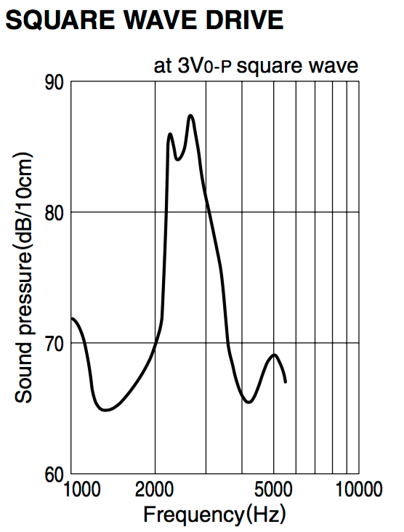

Table : Square Wave Drive for PS1927P02 Piezo Sounder

We considered this Piezo buzzer because the sound pressure level was high enough to where it would work in different types location specified in table 1.1. Also, the cost of this buzzer was cheap and would work with the budget. However, the SPL was only high between 2kHz and 3.5kHz, where at lower and higher frequencies the SPL was lower. So, this type of sounder didn’t give us a wider range frequencies to work with than the other buzzer types.

### PS1920P02 Piezo Sounder

This sounder is a low frequency tone buzzer with a maximum SPL at 80dBA/10cm min at 2 kHz, at 10Vp rectangular wave. This sounder has a maximum input voltage at 20Vp (without a DC bias). Table 2.2 shows a graph of the sound pressure corresponding to frequency.

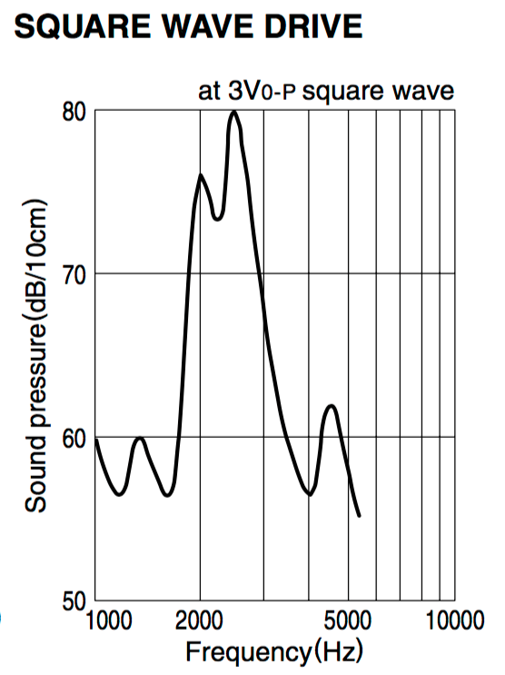

Table : Square Wave Drive for PS1920P02 Piezo Sounder

We considered this Piezo buzzer because the sound pressure level was high enough to where it would work in different types location specified in table 1.1. Also, the cost of this buzzer was cheap and would work with the budget. However, the SPL was only high between 2kHz and 3kHz. Also, this sounder had one of the lowest sound pressure level at the lower frequency than the other four sounders. As well as a low SPL at high frequencies. So, this type of buzzer didn’t give us a good range of frequency we could reach and still have a decent SPL that would work for different environments.

### PS1740P02E Piezo Sounder

This sounder is a high sound pressure buzzer with a maximum SPL at 75dBA/10cm min at 4 kHz, at 3Vp rectangular wave. This sounder has a maximum input voltage at 30Vp (without a DC bias). Table 2.3 shows a graph of the sound pressure corresponding to frequency.

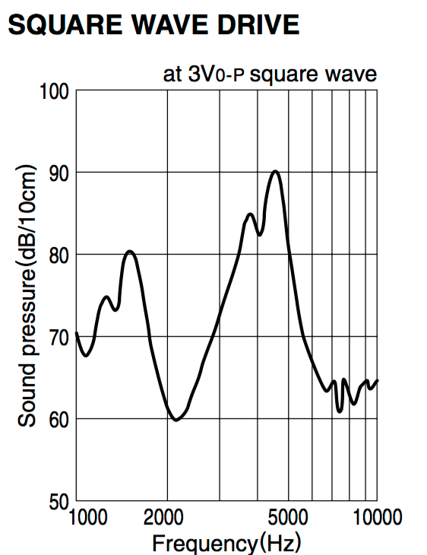

Table : Square Wave Drive for PS1740P02E Piezo Sounder

We chose this Piezo buzzer because the sound pressure level was high enough to where it would work in different types location specified in table 1.1. Also, the cost of this buzzer was cheap and would work with the budget. The frequency range that comes with this sounder is very broad which works well for this system. This sounder has a good sound pressure level with lower frequencies, which is good for private occupancies. As well as, a good sound pressure level with the higher frequency range that is good for public occupancies. Another reason as to why we chose this sounder is that the frequency gap where the SPL was really low was smaller between the other buzzers. So this sounder met a lot of specifications we needed so that is why we chose this one.

### 12 VDC PUI Programmable Buzzer

This sounder is a high sound pressure buzzer with a minimum SPL at 100 dBA/10cm min at 1 kHz. This sounder has an operating voltage ranging from 7 – 24 Vdc, as shown as in the table below. Table 2.4 shows a specification table of the programmable sounder.

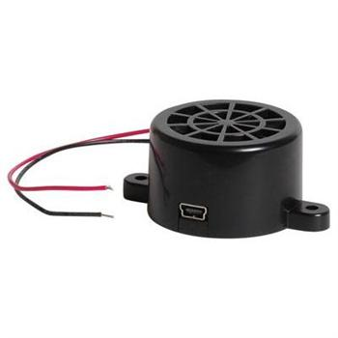

Figure : 12 VDC PUI Programmable Buzzer

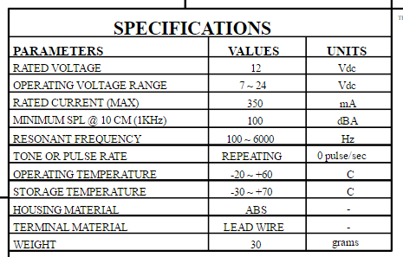

Table : Specifications for 12 VDC PUI Programmable Buzzer

We consider this 12Vdc PUI programmable buzzer because the sound pressure level was high enough to where it would work in different types location specified in table 1.1. However, the cost of this buzzer was a lot more expensive than the other buzzer that we were considering, so due to the cost it would increase our budget more than we wanted it to, because we would need to buy several of them for the fire alarm system. The great thing about this buzzer is that it’s adjustable so we would be able to change the different types of sounds that it makes, and we would be able to adjust the sound pressure level. Even though the cost was high, the frequency range that comes with this sounder is very broad, as shown in the table above the resonant frequency range is from 100 Hz to 6 kHz; which works very well for this system. This sounder has a good sound pressure level with lower frequencies, and since it is adjustable it would work for private occupancies. As well as, a good sound pressure level with the higher frequency range that is good for public occupancies. So even though this sounder met a lot of specifications we needed, the cost and the SPL was a little bit too high for the use.

## Wireless Communications

### 1.1 Overview

When it comes to wireless communication, there are many developments that have been made to the field in the past 20 years. Some of these developments include Wi-Fi (developed by the Wi-Fi Alliance, introduced in 1998), Bluetooth (introduced by Ericsson in 1994, developed by the Bluetooth Special Interest Group), and ZigBee (developed by Zigbee Alliance, introduced in 1998).

The S.M.A.R.T Alarm system will rely heavily on wireless communication, transmitting sensor data to the central processing and direction data back to the alarms. The following section will provide information on the aforementioned wireless communication options and will discuss the feasibility of their inclusion in the S.M.A.R.T Alarm system.

### 1.2 Wireless Fidelity (Wi-Fi)

As the most commonly used form of wireless communication, Wi-Fi is used in nearly every household in the world. A Wi-FI router covers an area, such as a household or business, with a blanket of Wi-Fi signal which allows any smart device to connect to the internet.

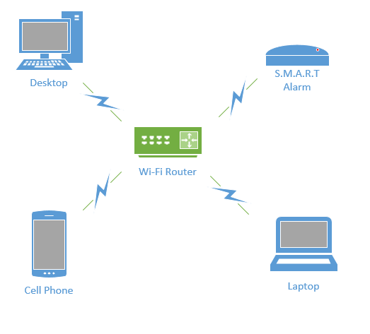

Figure : Wi-Fi Network

Introduced for commercial use in 1998, Wi-Fi is a Wireless Local Area Network (WLAN) that is based on the IEEE 802.11 standards. IEEE 802.11 is the radio frequency needed to transmit packets over radio links. These data packets are known as ethernet frames, which have built-in error checking. This means that if a data packet is altered or destroyed before it reaches its final destination, the packet will be resent until it is confirmed that it was received by its target.

IEEE 802.11b and 802.11g use the 2.4 GHz  industrial, scientific and medical (ISM) radio bands. Due to the choice of this frequency band, Wi-Fi devices occasionally experience interference by other RF devices and devices such as microwave ovens, cell phones, Bluetooth and Zigbee devices.

Spectrum assignments for the 2.4GHz band are not the same worldwide. For example, the U.S. only permits 11 channels for the 2.4GHz band to be operated without a license, whereas Australia and Europe allow two additional channels (12 and 13).  A Wi-Fi signal occupies five channels in the 2.4 GHz band, therefore it is only possible to have a group of three non-overlapping channels (Channels 1, 6 and 11) in the U.S.

All Wi-Fi certified devices will work with any Wi-Fi access point anywhere in the world, proved they can make it through the security checkpoints such as Wired Equivalent Privacy or WEP (which has been phased out due to weakness of security) or the more popular Wi-Fi Protected Acces[s](https://en.wikipedia.org/wiki/Wi-Fi_Protected_Access) (WPA and WPA2) which requires a passcode for access to the network.

Wi-Fi range is dependent on the frequency band, radio power output, antenna type and gain as well as the technique used in modulation. A Wi-Fi access point that complies with either the 802.11b or 802.11g protocols, using a stock antenna, can get a range of about 100 meters (330ft). However, using multiple access points such as multiple routers, allow for network redundancy and higher ranges.

Overall, Wi-Fi would be an excellent form of wireless communication for the S.M.A.R.T Alarms, if not for the power consumption of transmitting and receiving Wi-Fi signals. Because the S.M.A.R.T Alarms will be powered by batteries, a more power efficient communication system must be used.

### 1.3 Bluetooth

Bluetooth is a wireless communication technology used to transmit and receive data over short distances using short-wavelength UHF radio waves in the industrial, scientific and medical (ISM) bands (2.4 - 2.485 GHz). Most Bluetooth networks have a range of only about 10 meters (30 ft) depending on signal strength and obstructions, classifying their networks as Personal Area Networks (PANs). The IEEE standardized Bluetooth as IEEE 802.15.1, but no longer maintains the standard.

Bluetooth has a master-slave structure and is a packet based protocol. One master may communicate with up to 7 slaves, all the slaves sharing the master's clock. Bluetooth uses a frequency-hopping spread spectrum radio technology to transmit the data packets over one of 79 designated Bluetooth channels. Each one of these channels have a bandwidth of 1 MHz, and it usually transmits at 800 hops per second. Security in a Bluetooth system is very weak compared to other wireless communication systems, only relying on a four digit encryption, compared to the twelve digit encryption you get from Wi-Fi securities.

Due to the limited range (about 30 ft) and lack of proper encryption, associated with Bluetooth transmission, it is not feasible to use Bluetooth in the S.M.A.R.T. Alarm systems.

### 1.4 ZigBee

ZigBee is an IEEE 802.15.4 based high level wireless communication system. ZigBee creates Personal Area Networks (PANs) with relatively small low power radios. Used mostly in home automation and other low-power low-bandwidth application, ZigBee communication is great for small scale projects that need wireless communication. ZigBee was designed to be more simple and less expensive than other wireless PANs, like Wi-Fi or Bluetooth.

Due to ZigBee’s low power consumption, it limits transmission ranges to about 10-100 meters depending on power output and environment. However, through the use of a mesh network, data can be transferred from one device to another, allowing for an expansive range.

ZigBee operates in the ISM radio bands (2.4 GHz) with data transmission rates varying from 20 kbit/s for the 868 MHz band to 200 kbits/s at the 2.4 GHz band. ZigBee can support both star and tree networks, as well as generic mesh networking. Every ZigBee network must have one coordinating device which essentialyl creates the network environment, control over the network parameters and basic maintenance of the system. In a star network, the coordinating device must be the central node, in contact with all other devices. However, tree and mesh networks both allow use of ZigBee routers to extend communication at a network level.

ZigBee builds on IEEE 802.15.4 standards of physical layer and media access control for low rate PANs. There are four key components in addition to the set standards. Those additions are a network layer, application layer, manufacturer defined applications, and ZigBee device objects. These additions allow for customization and total integration of a system. ZigBee device objects or ZDOs are responsible for keeping track of device roles, managing network join requests as well as device discovery and security.

There are three kinds of ZigBee devices:

* ZigBee Coordinator - Described Above
* ZigBee Router - Runs applications as well as acting as intermediate router in a mesh or tree network. Requires less memory than Coordinator but more than End Device. Power consumption higher than that of End Device.
* ZigBee End Device - Has just enough functionality to communicate with parent node (Coordinator or Router). Cannot relay data from other devices. Gives the best battery life due to lack of need for communication and ability to enter sleep mode.

Software for ZigBee is designed to be easy to develop on small, inexpensive microprocessors, which will cut down on costs as well as time needed to set up the network. This is important when it comes to budgeting, as well as creating a product that is cost efficient and reasonably priced for a consumer.  Since ZigBee has very low power usage and low data rate (250 kbit/s), it is a great communication tool for battery powered devices. Zigbee also has a great security system (128 bit symmetric encryption keys). These factors make it best suited for occasional data transfers from sensors or input devices.

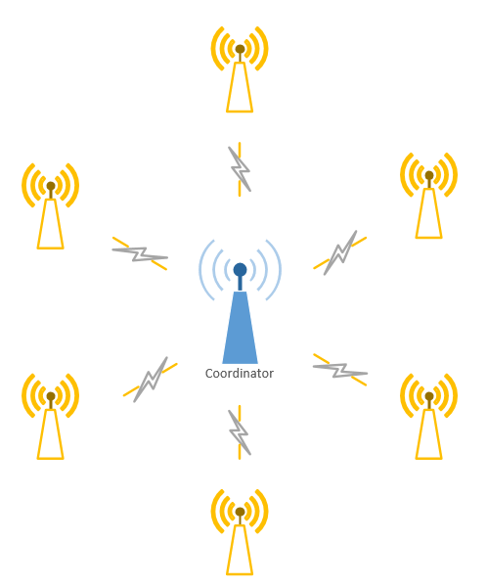

Figure : ZigBee Star Network

## Controller Hub

For our project, we would like to choose a development board that could be used as a hub for our smart fire alarm system. This hub would need to wirelessly send signals to the other fire alarm systems telling each alarm what direction to send users and when to go off. We decided on creating a hub for this system because without a hub, each fire alarm would need to be programed separately with its own location relative to the other alarms. Each alarm would also need to know it’s location relative to the suitable exits. With the use of the hub, we can choose one central system to program and do computation and that system would send the signals to the other alarms. A central hub would allow set up to go smoothly as a user would just have to set up the alarms and then program the hub with the locations of the alarms and exits. This greatly increases the ease of use for our system. A hub would also allow us to easily change the locations of our alarms after set up and also send software updates to the entire system easily. As ease of use and installation was an important factor for the design of our system, the choice for this unit is something that requires much research. When choosing a development board for projects, three units generally come to mind. These are the Arduino Uno, the Raspberry Pi, and the Beaglebone. We will evaluate each board, provide technical specifications for each, and weigh our options in the following text.

### Arduino Uno

The Arduino is a development board that has become extremely popular among the maker community to design small projects and perform prototyping on potential system ideas. The Arduino is a microcontroller that specializes in executing simple code directly with no operating system performing operations in the back ground. It specializes is connecting to sensors though it’s GPIO pins and sending simple signals through those pins to read data signals. The microcontroller that is included on the Arduino Uno development board is the ATmega328P which is designed by Atmel. It is a low-power CMOS 8 bit microcontroller that uses the RISC instruction set. The Arduino board has an operating voltage of 5 volts with a recommending input voltage of between 7 and 12 volts. The board contains 14 digital input output pins of which 6 of those provide output for pulse width modulation (PWM). (<https://www.arduino.cc/en/Main/ArduinoBoardUno)> It also includes 6 pins for analog input. The ATmega328P Atmel chip includes only 32 KB of flash memory of which 0.5 KB are used by the bootloader. This microcontroller ship has a clock speed of 16 MHz. (<http://www.atmel.com/Images/Atmel-42735-8-bit-AVR-Microcontroller-ATmega328-328P_Datasheet.pdf)> The power input specifications for this board allow it to be extremely low power and can be powered via a simple USB connection or with an external power supply. The reason this development board has become so popular among the maker community is that it is cheap and low powered while providing enough ease of use and input output pins to control external sensors. The board retails for $24.95 but can be very easily replicated using similar parts for much cheaper. The Arduino Uno does not come with build in wireless connections such as Bluetooth or Wi-Fi but comes with UART serial interface connections. The Arduino can communicate with a PC using original STK500 protocol. It features the Atmega16U2 programmed as a USB-to-serial converter and generally uses the Arduino IDE to be programmed.

Figure : Arduino Uno

### Raspberry Pi

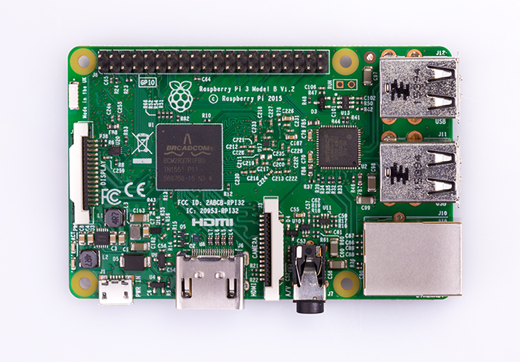While the Arduino board is a small affordable micro-controller, the Raspberry Pi can be considered the most popular micro-processor among community designers. Instead of just being able to do simple calculations the Raspberry Pi can be considered a full blown personal computer. This development board is powered by the Broadcom BCM2837 quad core Cortex A53 processor. This processor runs at a relatively speedy 1.2 GHz frequency. The Cortex A53 is capable of running both 32-bit and 64-bit instruction sets. It is based on the ARM architecture that has become very popular among smartphones and other small computing devices. The Raspberry Pi also comes with a VideoCore IV graphics processing unit that runs at 400 MHz. While this is not as powerful as most modern day PCs, this is more than enough processing power to run simple graphics processes and display them over the included HDMI connection. The board also comes with 1GB of build in LPDDR2 RAM for running multiple processes. The Raspberry Pi also comes with a microSD card slot and USB port for storing external memory. The newest Raspberry Pi 3 model also comes with a much-desired addition of wireless connectivity. Included on the board are a WiFi 802.11 b/g/n adapter running at 2.4GHz as well as a Bluetooth 4.1 LE transceiver and receiver. In terms of input/output capabilities, the Raspberry Pi comes with a 40-pin header of which 26 are general purpose IO pins. It also includes 1 UART pin for debugging and 2 pins that can be used for pulse width modulation. Two pins are also dedicated so a camera serial interface as well as a display serial interface. The device can be powered by 5 volts via a micro USB cable. The Raspberry Pi will take up 0.31 amps at 5V during idle mode with a Raspbian UI or 0.22 amps at 5.19 volts while using the terminal only in idle mode (<http://www.cnx-software.com/2016/03/01/raspberry-pi-3-odroid-c2-and-pine-a64-development-boards-comparison/>). One advantage that a board this powerful gives is its’ ability to run full 32 bit Linux distributions such as Ubuntu or Raspbian. This allows the programmer to design full applications that can be accessed via this device and a keyboard, mouse and monitor. Lastly, the Raspberry Pi retails for $35

Figure : Raspberry Pi

### BeagleBone Black

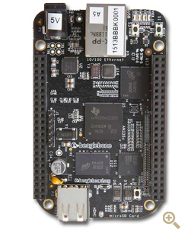The last development of the development boards up for consideration for use as the controller for our hub is the BeagleBone black. The BeaglebBone is a microprocessor development board similar to the Raspberry Pi. This board is powered by a AM3358 Sitara processor developed by Texas Instruments. This processor is based on the ARM Cortex A8 processor but is enhanced with image, graphics processing and other peripherals (​<http://www.ti.com/product/AM3358>). This processor runs at a 1GHz frequency and is capable of 2000 MIPS. The Beaglebone is also powered by a SGX530 3D graphics engine specifically designed for 3D rendering. This is more than enough processing power to be able to run a full functioning Linux distribution and in fact comes pre-loaded with Debian Linux with a 3.8.13-bone kernel. In terms of memory, this board comes with 512 MB of DDR3L RAM running at 606 MHZ and 4GB of onboard flash memory to hold code data and any other resources you might need. Interestingly, this board also comes with a TPS65217C dedicated power management module and optional 20 pin options JTAG serial header for debug support. It can be powered by miniUSB or a DC jack and uses 5V of DC power consumption. This board also comes with large amount of input/output access as it has two separate 46-pin headers of which 65 are GPIO and two are for pulse width modulation, a micro HDMI for audio and video output, and two USB ports. One thing that is of special note to this board, however, is that it contains a 10/100 Ethernet port but does not include built in Wi-Fi or Bluetooth capability. The last article of note is that this board retails for at least $55 from many different distributors (<https://www.adafruit.com/product/1876>).

Figure : BeagleBone Black

|  |  |  |  |
| --- | --- | --- | --- |
|  | Arduino Uno | Raspberry Pi 3 Model B | Beaglebone Black |
| Processor Speed | 16 MHz | 1.2 GHz | 1 GHz |
| Dedicated GPU | No | Yes | Yes |
| GPU Speed | N/A | 400 MHz | 200 MHz |
| Memory | 2 KB | 1GB | 512 MB of DDR3L |
| Input Voltage | 7-12 V | 5 V | 5V |
| Flash | 32 KB | SD Card | 4GB |
| Operating System | None | Linux Distributions | Linux Distributions |
| Multitasking | None | Yes | Yes |
| On board Wi-Fi | None | Yes | No, but Ethernet port |
| On board Bluetooth | None | Yes | No |
| GPIO Pins | 14 | 26 of 40 pin header | 65 of 92 pins |
| PWM Pins | 6 | 2 | 2 |
| USB | One, input only | Two ports | Two Ports |
| UART | Yes | 1 pin | 1 pin |
| On board HDMI | No | Yes | Yes |
| Price | $24.95 | $35 | $55 |

Table : Comparison of Development Boards

### Hub Comparison Conclusion

The development board we choose as our hub for the smart fire alarm system could very well be the most important piece of technology we choose for this project. This development board would be handling all of the computation for our system. This device would also be the central location from where all installation would be configured. An initial vision for our project is that customers would use the hub to configure and tell the system where the location of the smoke and fire alarm sensors are relative to each other as well as relative to the exits to the building. With this in mind, we have decided that this would make the Arduino Uno not the best choice to control the hub. Since the Arduino Uno does not have the processor speed or the capability to run an operating system, the Arduino would have to be connected to a computer in order for new updates or initial configuration to be handled. It also would have to be expanded with more flash memory and wireless peripherals in order for it to function as the hub. This would bring the price up to at least that of the Raspberry Pi while the Pi offers much more at this price point. Because the Raspberry Pi and Beaglebone Black have high amounts of processing power and graphics capabilities, these devices would have the ability to run full operating systems and function as a stand-alone service. This would eliminate the need for an installer or user to have a computer connected for set up and additional functionality. The installer would just have to connect a keyboard and screen to these devices for installation. This allows for the potential of developing an easy to use graphics program for set up in future development.

When just comparing the Raspberry Pi 3 and Beaglebone black, analysis shows that these two devices are very comparable. These devices have similar processor speeds, both contain a dedicated graphics processing unit, and both come with a substantial amount of on board memory. The Beaglebone does have 4GB of on board flash memory but that will be more than enough for our project while a Raspberry Pi can easily be expanded through the use of an SD card. The Raspberry Pi 3 comes with plenty of GPIO pins as 26 of the pins on the 40 pin header can be used as general purpose. The Beaglebone Black manages to more than double this amount with 65 pins which would be more than overkill for use as a wireless hub for our smart fire alarm system. The two places where a major difference between the Raspberry Pi 3 and Beaglebone Black finally start to show are the on board wireless connectivity and price points for each device. While the Raspberry Pi 3 comes with on board Wi-Fi and Bluetooth functionality, the Beaglebone bone falls short in this category. The Beaglebone only gives access to wired internet access through an Ethernet port. The Raspberry Pi would be able to provide wireless control over the sensors as well as download any updates or alerts over WiFi while the Beaglebone would need to be expanded to provide this. Lastly, while the Beaglebone may provide a large amount of GPIO pins and 4GB of RAM, we believe that these gains are not worth the $20 different in price that would be required versus the Raspberry Pi 3. The Raspberry Pi 3 provides everything our Hub would need while also having on board wireless connectivity for a price $35 while the Beaglebone Black retails for $55 or higher. For these reasons, we have chosen to use the Raspberry Pi 3 model B as the micro processing unit to control our hub.

## Fire Alarm Components

### Microprocessor for Fire Alarms

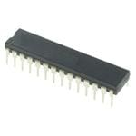Each fire alarm needs its own microprocessor to handle computing for the wireless signals and sensors that will be part of our smoke sensor design. The microprocessor will need to be low power and will not need a very high amount of processing power. For this reason, we have decided to use the ATmega328 microcontroller developed by Atmel. This chip is a low-power CMOS transistor microcontroller. The ATmega328 uses a simple 8-bit RISC architecture for executing simple instructions. This architecture is perfect for reading inputs from simple sensors and proving output signals to components such as LEDs. The RISC architecture that is used by the ATmega328 contains 131 instructions that operate in a single clock cycle. This microprocessor is capable of 20 million instructions per second when running at 20 MHz. Another important component of this chip is that is contains 23Kbytes of programmable flash memory. This memory is where the bootloader and functional code for our program will be stored. This flash memory is re-programmable allowing us to update and change the code as many times as needed during testing. The ATmega328 also comes with six sleep modes which may come in handy for us if we need to save battery life and power consumption on our system. This chip runs at an operating voltage of between 1.8 and 5.5V according to the data sheet provided by Atmel. The last of the important characteristics on this chip for our fire alarm system is that it contains 23 programmable I/O lines. These lines will be used to connect to the various peripherals of our alarm such as the buzzer, smoke sensors, LEDs, batteries, and wireless peripherals. One final reason that we chose this microprocessor is that it is the same one used in the Arduino Uno. This means that we can use a lot of the same resources that are provided with the Arduino Uno without having to worry about compatibility issues. Lastly, we can use an Arduino Uno to load a bootloader onto our chip alleviating the issues of choosing and writing our own bootloader. (http://www.atmel.com/Images/Atmel-42735-8-bit-AVR-Microcontroller-ATmega328-328P_Datasheet.pdf)

Figure : ATmega328P Microprocessor

#### Bootloader

Because we needed to purchase multiple microprocessors for use with many custom fire alarms we are going to build it was not feasible to purchase multiple Arduino Uno boards. This lead us to purchase ATmega328 processors that did not have a bootloader installed so we will need to install one ourselves. The purpose of a bootloader is to be a small program that runs when the system is powered on before the main program is run. This bootloader software will tell our fire alarm system to wait for the software on our programming computer to sent a new program to our fire alarm to be loaded. Our custom program would then be loaded into the flash memory on out ATmege328 processor. This bootloader is what will enable us to load programs onto out fire alarms using just a USB cable without the fire alarm going straight to running whatever program is installed on the system. Because we chose to use an ATmega328 microprocessor, we can use the same bootloader that is installed on Arduino Uno boards saving us a great amount of time in writing our own bootloaders. (<https://www.arduino.cc/en/Hacking/MiniBootloader)>. This also allows us to use the Arduino integrated development environment to program our fire alarms. Our team will only need to borrow an Arduino Uno for a short amount of time in order to create an unlimited amount of Arduino processors of our own.

#### Bootloading Process

Because our ATmega328 chips do not come with a bootloader preinstalled, we will need to install our own. Other than the obvious ATmega328, we will also need a few more components to install the bootloader onto the chip. We will need a breadboard for mounting the chip onto as well as a 16MHz crystal. This crystal in conjunction with two capacitors of about 22pF will act as a clock for our processor. Lastly, we will also temporarily need a working Arduino Uno in order to copy the bootloader over to our blank ATmega328 chip. The below diagram is an example of how an Arduino can be used to load the bootloader onto the chip:

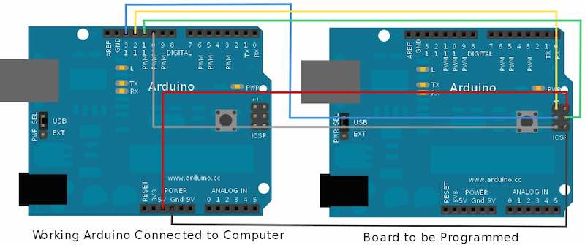

Figure : Arduino Loading Bootloader to Microprocessor

The first step for loading the bootloader is to place the ATmega328 chip into the middle of the breadboard allowing the pins on the left and right side of the chip to connect the two separated segments of the breadboard. The ATmega328 has a small indentation indicating which is the top of the chip, or rather which side pin one is on. This side should be oriented so that it is facing the top of the breadboard. VCC then needs to be connected to pin 7 and pin 20 which should be set to the input voltage of our ATmega328, 5 volts. Pins 8 and 22 on our chip need to be connected to ground. For designing our clock, we need to connect our 16MHz crystal to pins 9 and 10 on our board. Our capacitors that we have chosen need to be connected from each pin on the crystal to ground. Therefore, one capacitor needs to be connected to pin 9 and ground while another needs to be connected to pin 10 and ground. Our Arduino Uno board now needs to be connected to our computer using the USB connection on the board. The Arduino IDE comes with example sketches that can be loaded onto Arduino boards for testing purposes. One of these is called Arduino ISP and loads software onto the Arduino which will allow it to function as a bootloader for our ATMega328. This sketch needs to be uploading to our Arduino without any connections other than to the computer. Once this is complete the Arduino needs to be wired to our blank ATMega328 chip. The first connection is Pin 10 on the Arduino board which needs to be connected to the reset pin on our blank chip. The reset pin in Pin 1. Next, Pin 11 on the Arduino needs to be connected to pin 17 on our blank chip and Pin 12 on the Arduino needs to be connected to pin 18 on our blank chip. The last wire than needs to be connected is pin 13 on the Arduino which needs to be connected pin 19 on the blank chip and breadboard. Now we can connect our 5 volt VCC and ground and plug the Arduino back in to the computer. The last step is to go onto the Arduino IDE, confirm that the correct Arduino board is selected, which is the Arduino Uno, and select Burn Bootloader. This process should take a few minutes to complete. As long as no errors are shown on the Arduino IDE, an Arduino bootloader has now been loaded onto our chip and can be used by itself to program our project. (<https://www.youtube.com/watch?v=g90xb0nNX50>)

### 16 MHz Crystal Oscillator

The ATmega328 microprocessor that we are using to control our fire and smoke alarms will need a clock signal to control the processing speed of the circuit. The ATmega328 chip we are using does include an internal oscillator that can reach a maximum speed of 8MHz. Characteristics of the chip, however, describe that it can operate at a speed of up to 16MHz. An external oscillator would have to be used to reach this speed as the internal oscillator on the ATmega328 is only half as fast as the full capabilities of the chip. According to the AVR053: Internal RC Oscillator Calibration for tinyAVR and megaAVR Devicesdocument from Atmel <http://www.atmel.com/Images/Atmel-2555-Internal-RC-Oscillator-Calibration-for-tinyAVR-and-megaAVR-Devices_ApplicationNote_AVR053.pdf> , the internal RC clock can be calibrated to an accuracy of +/- 1% using software tricks. While this seems accurate, over the course of a year the timing of the clock could be off by as much as a day. This could create issues for a fire alarm system that needs to be online every minute of every day so ensure safety for those inside the building that it is installed in. This issue drives the need for an external crystal to be used. A cheap 16MHz crystal can be accurate to 0.005% on average right out of the box. This eliminates the issue with timing over the course of long periods of time allowing our signals and alarms to always be in sink. This is very important as one of the features of our system is the use of timed buzzer alarms signifying the correct direction to exit a building. It is also important to have a very accurate clock signal because we are using multiple microprocessors all connected to each other that will all be having their own clock signals with accuracy ratings. When multiple clocks are considered, the important of accuracy increases greatly. Another important reason to choose an external crystal over the included internal RC oscillator is that this internal oscillator is also more sensitive to temperature changes in the environment. As our system will inherently deal with temperature changes caused by a fire, we would want to choose the system that is most stable. This choice is the external crystal. There exist two pins on the ATMega328 dedicated to external crystal use. These are pins 9 and 10 on the left side of the chip. One drawback of the use of crystals, however, is that many times load capacitors must be included. These load capacitors ensure that the crystal begins to oscillate. Because of this, we will be using two 22pF capacitors each connected from each pin on the crystal to ground. A crystal is a device that by itself does not have any active capabilities. Because of this, external drivers will be needed to convert the crystal into an oscillator (<https://www.arduino.cc/en/main/standalone>). Thankfully, the ATMega328 includes this capability built right into the chip. This is the reason why there are dedicated crystal pins located on the chip.

# 4.0 Design Constraints and Standards

## Constraints

### Economic Constraints

### Environmental Constraints

### Social Constraints

### Political Constraints

### Ethical Constraints

### Health and Safety Constraints

### Manufacturability Constraints

### Sustainability Constraints

## Standards

# 5.0 Project Design

## Hardware Design

## Software Design

### Hub Software/Network Overview

For our Smart Fire Alarm system, the hub will be the most important processing unit. All of the fire alarms installed in the system will be using the same network sending data between Xbee modules to the hub system. Therefor the hub will be the coordinator for the network allowing all the fire alarms to connect to it. The most important aspect of the hub is that it will be doing all of the calculations needed to orchestrate the system.

The first important aspect of the software is that it will hold all important data regarding the number of alarms installed in the system as well as their locations. It will also hold the location of the suitable exits for the building that the system will be installed in. For each alarm installed in the system the hub will store information regarding the adjacent alarms or exits to each alarm. For example, the hub might store that alarm 2 has an exit directly to the north, alarm 3 directly to its right and alarm 1 directly to its left. It would then make sure that for alarm 1, alarm 2 is registered as being directly to its right. All of this information would have to be stored during installation of the system into a building. Once all of this information in stored, the hub will have a data blueprint of all alarms and exits inside the entire building and will have the knowledge necessary to direct people to the correct locations in the event of an emergency.

The next important aspect of the software is that it will be receiving signals from each of the fire alarms over the XBee wireless network. This means that when a sensor for an alarm reads that there is a hazard the fire alarm will send a signal to the hub that it needs to go off. The hub will save which XBee signal is correlated to which alarm so that it is aware of the specific alarm that goes off when it reads a signal. The hub will then use this information to know which specific alarm is going off and will join this with the above information to calculate the correct directions that people will need to travel through the building to reach the best exit.

A quick explanation of how the hub calculated the directions to send out to the alarms will now be provided. In the event that the hub receives a signal from an alarm that it is going off, the hub will start at that alarm and calculate the today distance to an exit in each of the possible directions that a person can go from this alarm that is going off. For example, if the alarm has two possible directions that you can go from this alarm it will add the distance to the next adjacent alarm to the distance that it calculates it takes to get to the next closest exit from that adjacent alarm. The system will than continue to do this calculation all the way down until it reaches an exit. The returned value would be the total distance to an exit if you go that direction. It would then do this for the other direction and decide which direction has the smallest distance. The beauty of this type of algorithm is that, as long as there is one continuous path from one alarm to all of the others, the system would have calculated the best direction to go to from each alarm throughout the entire system. This type of algorithm is what is known as a recursive algorithm. The hub would then have all the information it needs to send the correct signals out to all the alarms in order to send everyone to the proper exits no matter where you are located throughout the building.

The last important aspect of the system is the sending of signals to each individual alarm. The system will send two important signals to each alarm in the event of an emergency. After the system decides the proper directions to send out to each alarm the hub will send out the signal to each alarm of which LED arrow to light up. This will be the visual que for users to know which direction to go. The LED signals sent out by the hub will follow the decisions that were made earlier of which is the best direction to travel to reach an exit. Secondly, the hub will calculate the order of buzzer sounds to send out in order to send audio ques to users of which direction to head. The hub will do this by saving the “level” of each alarm from the fire. What this means is that while calculating the directions, the hub will also calculate the order of the alarms. It will keep track of the first alarm that is traveled to from the fire, then the second, then third and so on. It will use this information to send the buzzers off for each alarm in order with a delay in between. This delayed audio signal will be what a user can follow to expedite the process of figuring out the best way for them to exit a building. Lastly, the hub will also have a reset signal that can be sent out to all of the alarms in order to reset the alarms. This means turning off the LEDs for each alarm as well as turning off the buzzer sounds. This reset can either be set to go off after a certain amount of time or directly on the hub via a user sent signal.

## Wireless Network Design

# 6.0 Administrative Content

## Estimated Budget

|  |  |
| --- | --- |
| Wireless Adapters | $10 x 5 = $50 |
| Battery Harness / Power Supply | $3 x 5 = $15 |
| Speaker/Alarm | $1 x 5 = $5 |
| Various Electrical Components | $10 x 5 = $50 |
| Microcontroller for Hub | $30 x 1 = $30 |
| PCB boards | $10 x 5 = $50 |
| Smoke Sensors | $7 x 5 = $35 |
| Boot flasher | $15 x 1 = $15 |
| Estimated Total | $250 |

Table : Estimated Budget

The initial estimated cost for this smart smoke detector project is $250. We will add an additional $50 to this budget to account for broken parts, errors, and items that are unaccounted for. This brings the total cost of our project to $300.

## Actual Expenditures: Prototype

## Financing Plan

While everyone on the team has agreed to share any financial burden created by the project equally, we will seek sponsorships and other means to finance this project. After selecting a project, and receiving approval we have created a prototype of our system at the time financed by the group members. This allows a very accurate estimate of the costs the final implementation of the project for presenting at the Senior Design Showcase. Once this estimate is ready and we need to enter production of our final product we will submit proposals to companies interested in investing in a smart system for fire safety and those looking to showcase their semiconductor and component products. A tentative list includes: Texas Instruments, Taiwan Semiconductor Manufacturing, Honeywell Fire Systems, Siemens (Building Technology Division), and UCF. If no sponsorship or financial help is achieved, the team is willingly responsible for any costs incurred.

## Project Timeline

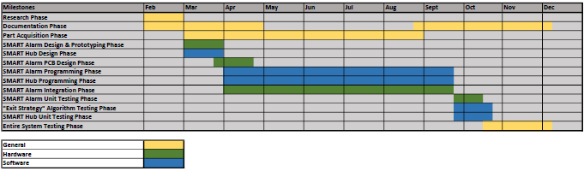

# 7.0 Conclusion

# 8.0 Appendix

## 8.1 References

**[1]** Bukowski, Richard W., Richard D. Peacock, Jason D. Averill, Thomas G. Cleary, Nelson P. Bryner, William D. Walton, Paul A. Reneke, and Erica D. Kuligowski. *Performance of Home Smoke Alarms*. Rep. National Institute of Standards and Technology, Feb. 2008. Web. 25 Feb. 2017.

**[2]** Cote, Arthur E., and Percy Bugbee. *Principles of fire protection*. Quincy, MA: National Fire Protection Association, 1995. Print.

**[3]** Alt, Kimberly. "Find the Best Smoke Detector Type for Your Family." *ASecureLife.com*. A Secure Life, 12 May 2016. Web. 25 Feb. 2017. <http://www.asecurelife.com/best-smoke-detector/>.

**[4]** Jain, Vaibhav. "Learn the Working of a Gas Sensor." EngineersGarage. EngineersGarage, n.d. Web. 21 Mar. 2017. <https://www.engineersgarage.com/insight/how-gas-sensor-works>.

**[5]** "Types of Smoke Detectors and Alarms." *Grainger Industrial Supply*. W. W. Grainger, Inc., n.d. Web. 25 Feb. 2017. <https://www.grainger.com/content/qt-types-smoke-alarms-detectors-366>.

**[6]** "International Association of Fire Fighters (IAFF)." *International Association of Fire Fighters (IAFF)*. World Fire Safety Foundation, Aug. 2008. Web. 25 Feb. 2017. <http://www.thewfsf.org/iaff>.

**[7] C**ox, James F. Fundamentals of Linear Electronics: Integrated and Discrete. Albany, NY: Delmar, 2002. Print.

**[8]** Tavernier, Filip, and Michiel Stevaert. “Chapter 3: From Light to Electric Current – The Photodiode.” High-speed Optical Receivers with Integrated Photodiode in Nanoscale CMOS. NewYork: Springer, 2011. N. pag. Print.

**[9]** Nave, Carl. "Photodiode Light Detector." *Photodetectors*. HyperPhysics, n.d. Web. 07 Mar. 2017. <http://hyperphysics.phy-astr.gsu.edu/hbase/Electronic/photdet.html>.

## 8.2 Copyright Permissions

## 8.3 Datasheets